## 1. **Monthly Customer Rank by Spend**    - For each month (based on `order_date`), rank customers by **total order value** in that month using `RANK()`.    - Output: month (YYYY-MM), customer_id, total_monthly_spend, rank_in_month.

SELECT

TO_CHAR(*o*.order_date, 'YYYY-MM') AS *month*,

*c*.customer_id,

SUM(*oi*.quantity * *oi*.unit_price) AS *total_monthly_spend*,

RANK() OVER (PARTITION BY TO_CHAR(o.order_date, 'YYYY-MM') ORDER BY SUM(oi.quantity * oi.unit_price) DESC) AS *rank_in_month*

FROM training_ecom.customers *c*

JOIN training_ecom.orders *o* ON *c*.customer_id = *o*.customer_id

JOIN training_ecom.order_items *oi* ON *o*.order_id = *oi*.order_id

WHERE *o*.status != 'cancelled'

GROUP BY TO_CHAR(*o*.order_date, 'YYYY-MM'), *c*.customer_id

ORDER BY *month*, *rank_in_month*;

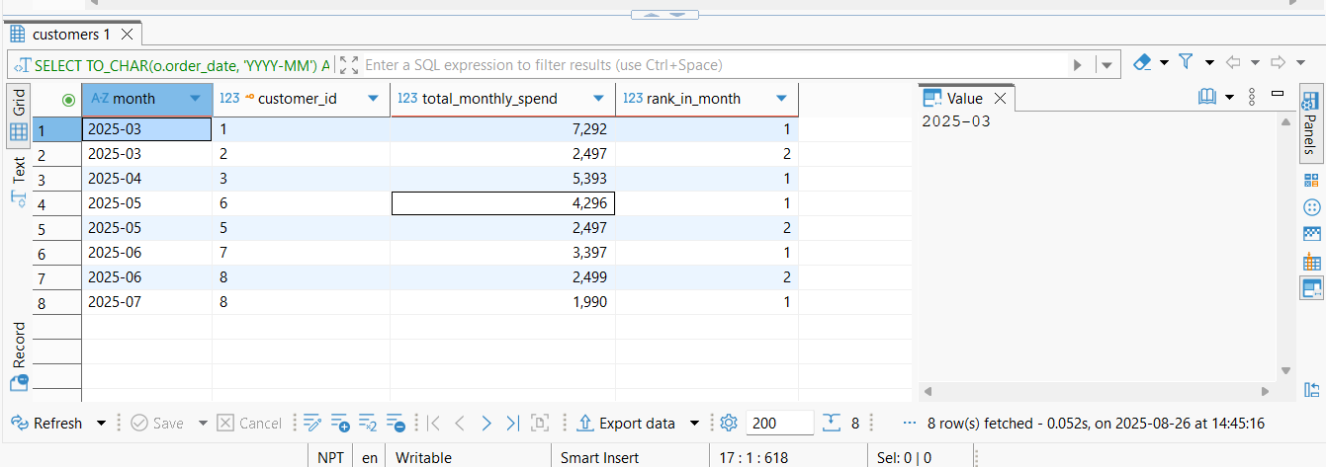

## 2. **Share of Basket per Item**    - For each order, compute each item's **revenue share** in that order:      `item_revenue / order_total` using `SUM() OVER (PARTITION BY order_id)`.

**SELECT**

*oi*.order_id,

*oi*.product_id,

*p*.product_name,

(*oi*.quantity * *oi*.unit_price) **AS** *item_revenue*,

(*oi*.quantity * *oi*.unit_price) / **SUM**(*oi*.quantity * *oi*.unit_price) **OVER** (**PARTITION** **BY** oi.order_id) **AS** *revenue_share*

**FROM** training_ecom.order_items *oi*

**JOIN** training_ecom.products *p* **ON** *oi*.product_id = *p*.product_id

**JOIN** training_ecom.orders *o* **ON** *oi*.order_id = *o*.order_id

**WHERE** *o*.status != 'cancelled'

**ORDER** **BY** *oi*.order_id, *oi*.product_id;

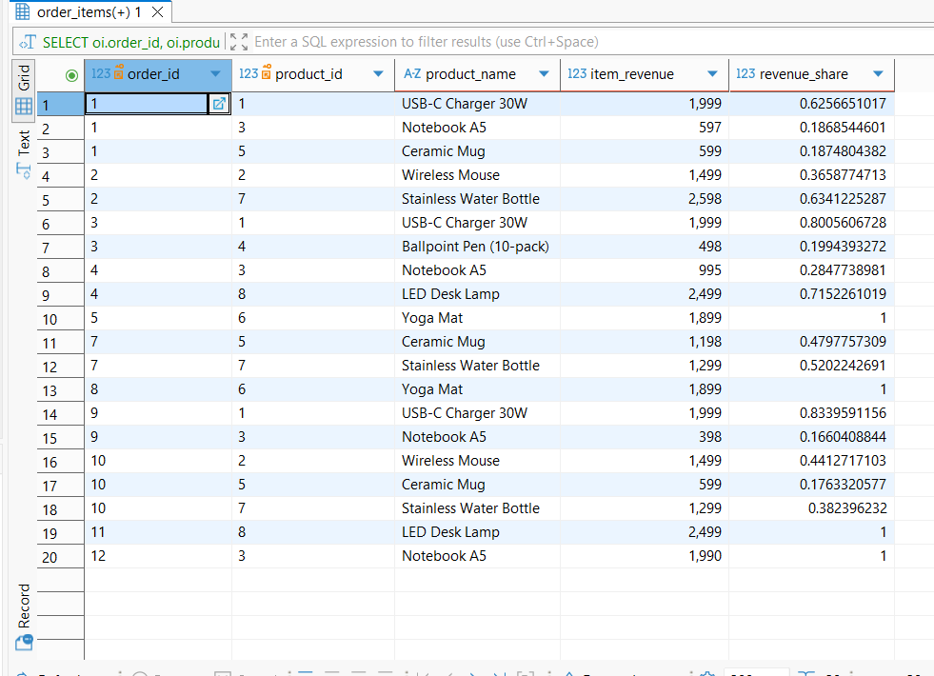

**3. **Time Between Orders (per Customer)**  
   - Show days since the **previous order** for each customer using `LAG(order_date)` and `AGE()`**

**SELECT**

*c*.customer_id,

*c*.full_name,

*o*.order_id,

*o*.order_date,

**LAG**(*o*.order_date) **OVER** (**PARTITION** **BY** c.customer_id **ORDER** **BY** o.order_date) **AS** *previous_order_date*,

**AGE**(*o*.order_date, **LAG**(*o*.order_date) **OVER** (**PARTITION** **BY** c.customer_id **ORDER** **BY** o.order_date)) **AS** *days_since_previous*

**FROM** training_ecom.customers *c*

**JOIN** training_ecom.orders *o* **ON** *c*.customer_id = *o*.customer_id

**WHERE** *o*.status != 'cancelled'

**ORDER** **BY** *c*.customer_id, *o*.order_date;

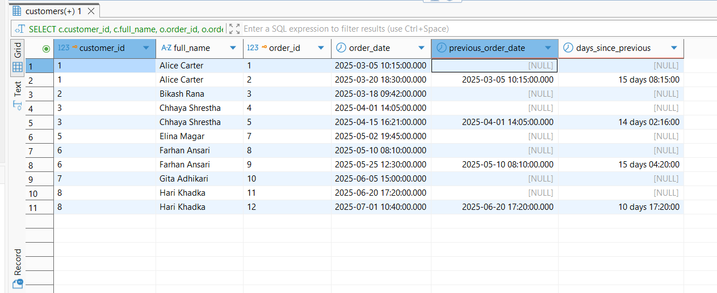

**4. **Product Revenue Quartiles**  
   - Compute total revenue per product and assign **quartiles** using `NTILE(4)` over total revenue.**

**SELECT**

*p*.product_id,

*p*.product_name,

**SUM**(*oi*.quantity * *oi*.unit_price) **AS** *total_revenue*,

**NTILE**(4) **OVER** (**ORDER** **BY** **SUM**(oi.quantity * oi.unit_price)) **AS** *revenue_quartile*

**FROM** training_ecom.products *p*

**LEFT** **JOIN** training_ecom.order_items *oi* **ON** *p*.product_id = *oi*.product_id

**LEFT** **JOIN** training_ecom.orders *o* **ON** *oi*.order_id = *o*.order_id **AND** *o*.status != 'cancelled'

**GROUP** **BY** *p*.product_id, *p*.product_name

**ORDER** **BY** *total_revenue* **DESC**;

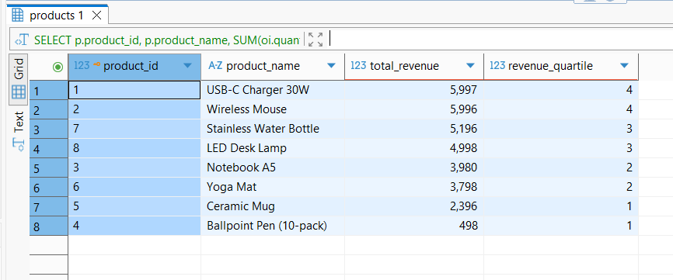

## 5. **First and Last Purchase Category per Customer**    - For each customer, show the **first** and **most recent** product category they've bought using `FIRST_VALUE` and `LAST_VALUE` over `order_date`.

**SELECT** **DISTINCT**

*c*.customer_id,

*c*.full_name,

**FIRST_VALUE**(*p*.category) **OVER** (**PARTITION** **BY** c.customer_id **ORDER** **BY** o.order_date **ROWS** **BETWEEN** **UNBOUNDED** **PRECEDING** **AND** **UNBOUNDED** **FOLLOWING**) **AS** *first_category*,

**LAST_VALUE**(*p*.category) **OVER** (**PARTITION** **BY** c.customer_id **ORDER** **BY** o.order_date **ROWS** **BETWEEN** **UNBOUNDED** **PRECEDING** **AND** **UNBOUNDED** **FOLLOWING**) **AS** *last_category*

**FROM** training_ecom.customers *c*

**JOIN** training_ecom.orders *o* **ON** *c*.customer_id = *o*.customer_id

**JOIN** training_ecom.order_items *oi* **ON** *o*.order_id = *oi*.order_id

**JOIN** training_ecom.products *p* **ON** *oi*.product_id = *p*.product_id

**WHERE** *o*.status != 'cancelled'

**ORDER** **BY** *c*.customer_id;

